Files and Streams
Lecture 7
Instructor Notes
I. Input and Output
- The java.io package provides an extensive library of classes for dealing with input and output. Java provides streams as a general mechanism for dealing with data I/O. Streams implement sequential access of data. There are two kinds of streams: byte streams and character streams.
- Definition of a Stream:
  - A stream is a sequence of characters or bytes
    - Read from input streams – An input stream is an object that an application can use to read a sequence of data; it acts as a source of data.
    - Write to output streams – An output stream is an object that an application can use to write a sequence of data; it acts as a destination or sink of data.
    - Character Streams: The abstract classes Reader and Writer are the roots of the inheritance hierarchies for streams that read and write Unicode characters using a specific character encoding.
    - Byte Streams: The abstract classes InputStream and OutputStream are the root of the inheritance hierarchies for handling the reading and writing of bytes. Their subclasses, which implement different types of input and output streams, override the methods list below to customize the reading and writing of bytes, respectively.
    - IMPORTANT: Streams can be chained with filters to provide additional functionality.
  - Kinds of streams
- Files
- Network connections (Sockets); also known as pipes
- Memory buffers (such as byte arrays or character arrays)
- Read and write operations on streams are synchronous (blocking) operations, i.e., a call to a read or write method does not return before a byte has been read or written.
  - Basic stream methods
- read() - Three flavors: buffer, sub-buffer, single element
      - returns -1 if end of stream reached
- write() – mirrors most of the read methods (buffer, sub-buffer, single element)
- flush() - Forces the stream to be written
- close() - Closes the stream; it actually does a flush and a close.
      - ALWAYS do this explicitly!!!
- Place in a finally block to ensure that the IO port will be closed.
- A stream should be closed when no longer needed, to free system resources.
- Closing an output stream automatically flushes the stream, meaning that any data in its internal buffer is written out. An output stream can also be manually flushed by just calling the flush() method.
      - The Stream Class Hierarchy
A. The Stream Class (base classes) has 2 hierarchies in the java.io package:
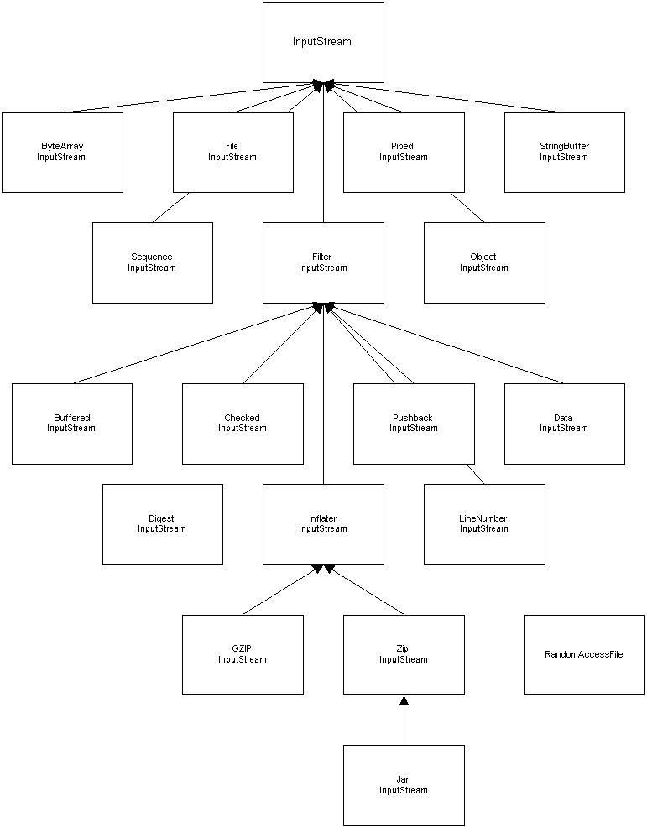

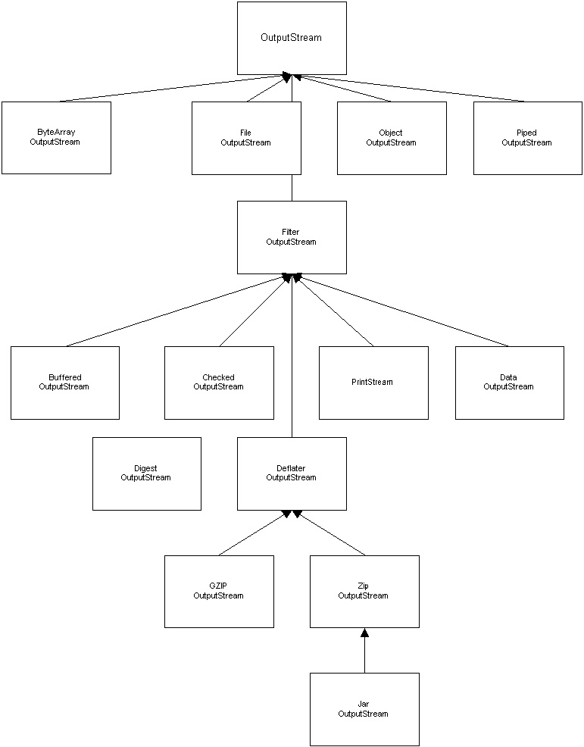

- Kinds of Streams & Readers
  - A small sample of different types of Streams and Readers
- FileInputStream/FileOutputStream, FileReader/File Writer Read and write files
  - Put filename in constructor
  - FileOutputStream/FileWriter will overwrite an existing file
  - The classes FileInputStream and FileOutputStream define byte input and output streams that are connected to files. Data can only be read or written as a sequence of bytes. You must make sure that the file has permissions set to read or write from it. Otherwise, a SecurityException will be thrown.
    - Example together in class.
- InputStreamReader/OutputStreamWriter
  - Converts from bytes to Unicode and vice versa
    - By default, uses the character encoding of the local operating system
- StringBufferInputStream/StringBufferOutputStream, StringReader/StringWriter
  - Read from or write to a StringBuffer
- PipedInputStream/PipedOutputStream, PipedReader/PipedWriter
  - Used to connect input streams to output streams
    - UNIX pipe commands
- RandomAccessFile
  - Read and write anywhere in a file
  - Can be opened as read-only or read/write
    - Use “r” in constructor for read-only
    - User “rw” in constructor for read/write
    - Cannot be used with filter chains!
    - Does not replace file
      - Append to files by seeking to the end
    - Methods
      - Method: getFilePointer(): Returns the current position
      - Method: seek(): Number of bytes to offset into the file
      - Method: length(): Returns the length of the file
- Filter Streams
  - Allows you to chain functionality by layering filters around streams or other filters
- Definition - A filter is a high-level stream that provides additional functionality to an underlying stream to which it is chained. The FilterInputStream and FilterOutputStream classes, together with their subclasses, define input and output filter streams. For example, DataInputStream and DataOutputStream implement filters that allow Java primitive values to be read and written respectively to and from an underlying stream. The DataInputStream contains methods like readBoolean(), readFloat(), readInt(), etc. Whereas, the DataOutputStream contains methods like writeBoolean(), writeFloat(), and writeInt().
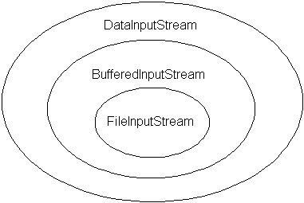
- So, here’s how it works, you first create an underlying stream, in the picture above, that would be the FileInputStream, so our stream source is, obviously, a file. Then, we chain the BufferedInputStream to the FileInputStream in order to read a block of bytes at a time instead of reading one byte at a time. Then, we chain DataInputStream to the BufferedInputStream in order to now be able to invoke some convenient methods we need like readLong(), readShort(), etc., using the appropriate method for the matching datatype found in the file. Finally, the last step in this is to close the inputStream. In this case, if you close the DataInputStream, all the underlying streams will be closed as well.
    - Based on the “Decorator Pattern”
      - Flexible
        - Allows you to only add the functionality you need
- Filter constructors require an InputStream/OutputStream object as a parameter
- No default constructor
- First filter must be wrapped around a real stream
  - Other filter can be wrapped around this filter
- Example:
DataInputStream din = new DataInputStream(
new BufferedInputStream(
new FileInputStream(“employee.dat”) ) );
4. Order of layering matters!
  - Put BufferedInputStream closer to source
- Kinds of Filters:

- BufferedInputStream/BufferedOutputStream, BufferedReader, BufferedWriter
- Buffers data for read/write efficiency
- DataInputStream/DataOutputStream
- Reads/writes primitive data types (binary)
- PushbackInputStream, PushbackReader
  - Good for looking ahead in the input
      - unread()
- ObjectInputStream/ObjectOutputStream
1.Read or or write any object to a stream
        - The class must implement Serializable (no methods)
        - VERY USEFUL!
        - Basis of RMI
        - writeObject()
          - Writes object and any object contained (has-a relationship) by this object
        - readObject() – returns Object reference
            - You must cast to the real object type
            - Modifying the class after writing the object causes version problems
- ZipInputStream/ZipOutputStream, JarInputStream/JarOutputStream
  - Compresses and combines files using the ZIP format
- Character Streams: Readers and Writers
- A character encoding is a scheme for representing characters. Java programs represent characters internally in the 16-bit Unicode character encoding, but the host platform might use another character encoding to represent characters externally (outside of the program). For example, ASCII is a subset of the Unicode standard. In other words, when a Java program reads in data, it converts it to 16-bit Unicode to be manipulated. But, when writing the data back out, it will decode it back into the platform-specified character-encoding scheme.
    - The abstract classes Reader and Writer are the roots of the inheritance hierarchies for streams that read and write Unicode characters using a specific character encoding.
    - A reader is an input character stream that reads a sequence of Unicode characters, and a writer is an output character stream that writes a sequence of Unicode characters. Readers and writers to convert between external encoding and internal Unicode characters use character encodings.
- PrintStream, PrintWriter
    - Print lines of data to the stream
      - print(), println()
      - autoflush mode set in constructor
      - A filter that allows textual representation of Java objects and Java primitive values to be written to an underlying output stream or writer. The underlying output stream or writer must be specified.
      - Example:
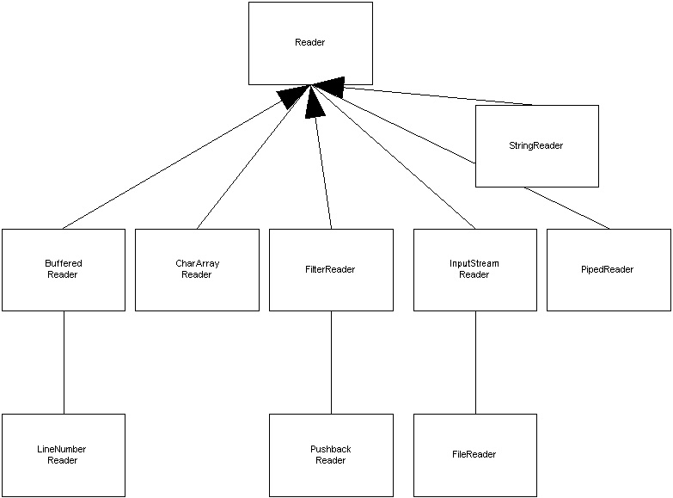
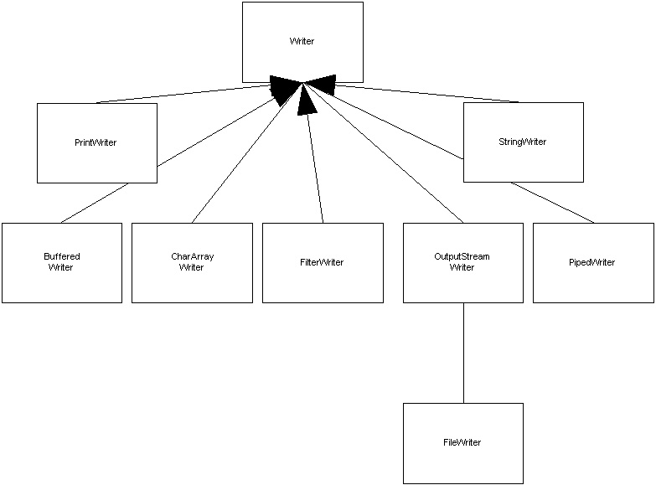

File Management
- The File Class
- The File class provides a general machine-independent interface to the file system of the underlying platform.
- A File object represents the pathname of a file or directory in the host file system.
- The File class is NOT meant for handling the contents of files. For that purpose, there are the FileInputStream, FileOutputStream and RandomAccessFile classes.
- The pathname for a file or directory is specified using the naming conventions of the host system. However, the File clas defines platform
- Allows you to:
  - Determine if a file exists- exists()
  - Check to see if it is a directory- isDirectory()
  - Get the file length- length()
  - List the files in a directory- list()
  - Create a directory- mkdir(), mkdirs()
  - Rename a file- renameTo()
  - Delete a file- delete()

